1.1 Given an array of strings words, return the first palindromic string in the array. If there is no such string, return an empty string "". A string is palindromic if it reads the same forward and backward.

AIM
To design a Python program that finds and returns the first palindromic string from a list of words.
ALGORITHM
- Start with the given list of words.
- Traverse each word in the list sequentially.
- For each word, check if it is equal to its reverse.
- If yes, return that word immediately.
- If no palindrome is found after traversing the entire list, return an empty string "".

PROGRAM
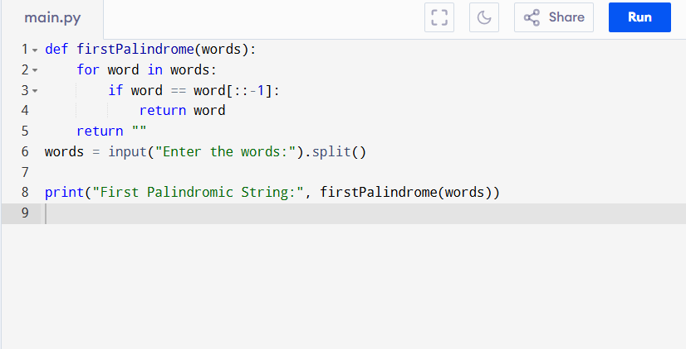

Input:
An array of strings.
["abc", "car", "ada", "racecar", "cool"]

Output:
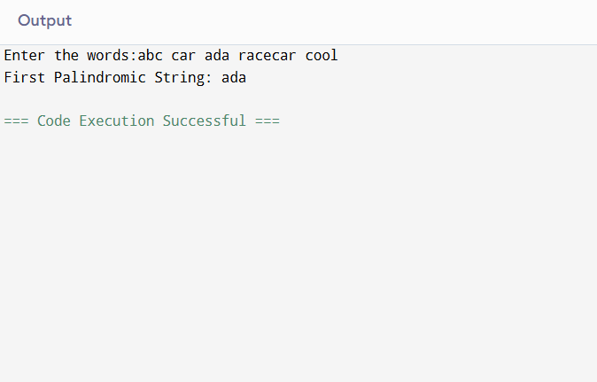
RESULT:
Thus the first palindromic string in the array program is successfully executed and the output is verified.

PERFORMANCE ANALYSIS:
- Time Complexity:
  - Checking each word takes O(n) where n is the length of the word.
  - For m words, worst case = O(m * n).
- Space Complexity:
  - Uses only a few variables, so O(1) (constant extra space).

